**School of Electrical and Electronic Engineering**



Embedded Systems Project

DESIGN REPORT #1

Title: ?

Group Number: ?

|  |  |  |
| --- | --- | --- |
| Group members name: | ID Number | I confirm that this is the group’s own work. |
|  |  |  |
|  |  |  |
|  |  |  |
|  |  |  |
|  |  |  |

Tutor: Click here to enter text.

Date: Click here to enter a date.

Contents

1. Introduction 1

2. Motor characterisation 1

3. Load measurements 1

4. Gear ratio selection 1

5. Summary 1

6. References 1

## Software System

The software will be implemented on an STM32F401RE board. Because of this particular board, the potential software constraints can be 512kB of flash storage, 96kB of RAM and 84MHz system clock. This signifies that the entire program size must not exceed 512kB and the RAM can be a limiting factor to holding a number of sampled data while the control algorithm performs calculations on that data. An 84MHz clock suggests that the sampling rate of the sensors will generally be a fraction of that and with a clock period of 0.0019 seconds, the precision of movements may be limited. The following abbreviations are members of the case diagram. These act as an abstract input and output sources. Some have both functionalities, such as using sensors (to switch on/off and perceive curves and track).

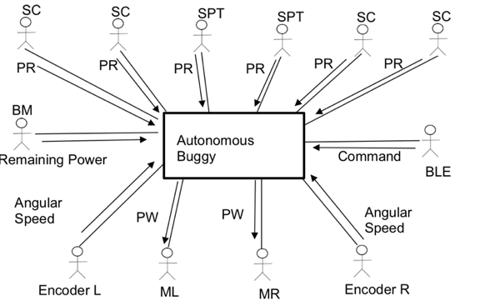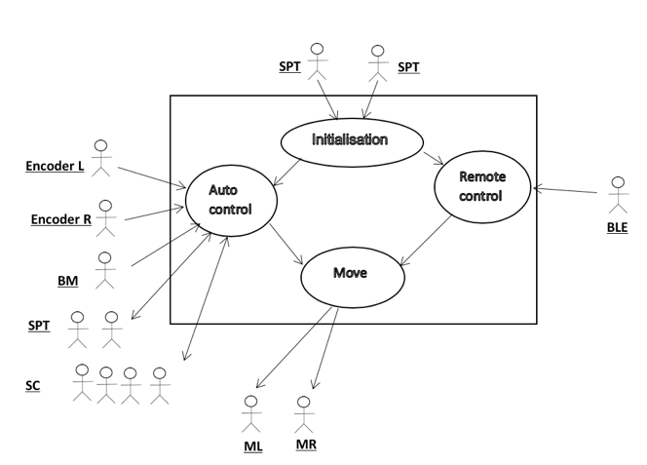

Figure **Error! No text of specified style in document.**. Messages exchanges between actors and system(see left) and Interaction between the external objects and the system (see right).

* SPT: Sensors for Perceiving the Track.
* SC: Sensors for Curving
* PRL: Position with respect to the line.
* PWM: Pulse wave modulation.
* M (R, L): Right Motor, Left Motor.
* BM: Battery Monitor
* BLE : Bluetooth Low Energy to make changes due to user remote input.

SC is made up of 4 separate sensors that follow curves. These are sensors 1,2,3 and 4 in figure 2.x. These sensors can be individually switched on and off in software to lower power consumption and effects of crosstalk. SPT are made up of 2 separate sensors 5 and 6 (in figure 2.x) that perceive the track and are for safety purposes where they inform the auto control algorithm to make immediate adjustments.

The following is an object specification of how the buggy performs according to the series of inputs and outputs.

WHILE NOT finished  
 Wait for detection of white line

While (detection of white line) { Input:

Position with respect to the line from SPTs

Position with respect to the line from SCs

Angular speed from Encoders  
 Check Command from BLE to override control algorithm

Remaining power from BM

Execute control algorithm

Output:  
 PWM to MR

PWM to ML

} ELSE Finished=TRUE

## Sensor Characterisation

Using a combination of receiver and emitter components, tests were conducted to characterise each combination.

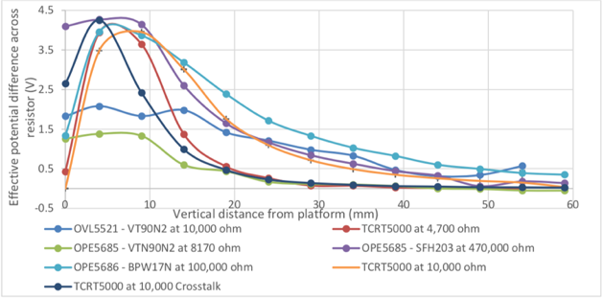

Figure **Error! No text of specified style in document.**. A graph comparing effective voltage difference of sensors at varying heights (see left) and linespread characteristics of the sensors (see right)

The TCRT5000 sensor at 10,000 ohms performs reliably over a large distance and does not saturate as quickly as the OPE5685-SFH203 combinations. With the inbuilt crosstalk shield, smaller footprint and low latency, the TCRT5000 was selected as the sensor of choice by the group. This sensor was implemented on a digital sensor board using 2 quad comparators and a Darlington chip array to allow individual power on/off capabilities.

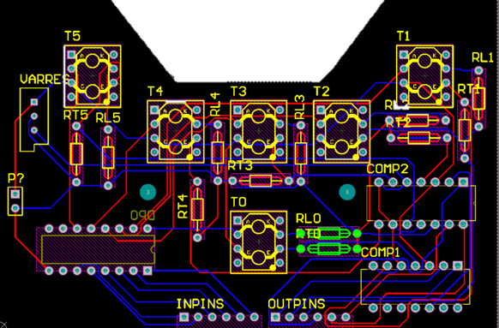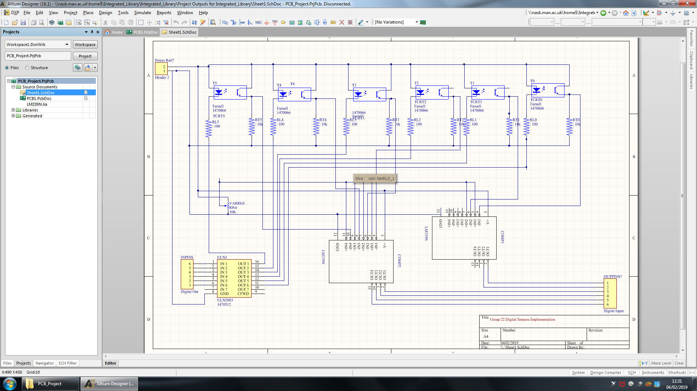

Figure **Error! No text of specified style in document.**. Schematic of digital sensor circuit (see left) and PCB design(see right).

## Control Algorithms Selection

While ‘bang-bang’s immediate switch on/off states can be useful in situations where abrupt turns occur, proportional allows a larger flexibility, allowing inter-state regions. Resulting in refined and smoother turns. ‘The Proportional-Integral-Derivative controller adds specific functionalities that increase the accuracy of turn detection. The proportional part allows the controller to maintain stability by decreasing current error under a steady state. The ‘integral’ part analyses previous errors and rejects random noise. ‘Derivative’ on the other hand has the ability to predict future errors.

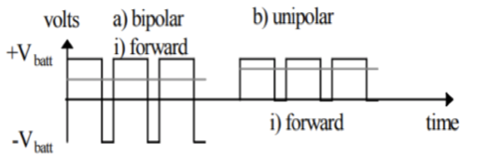

Figure **Error! No text of specified style in document.**. shows both unipolar and bipolar modes in forward direction.

The buggy will utilise a rear-wheel drive transmission with the variable speed motors acting as a pivot to allow the buggy to manoeuvre. The motors are powered and controlled by the motor drive board using the h-bridge circuit in uni-polar mode. Uni-polar, compared to bipolar, is a superior mode which allows huge reductions in power loss due to lower conduction losses. The fine control of the motors is performed in software.

There is also an important choice of developing algorithms using analogue or digital sensing. Typically, due to sampling limitations, digital sensing can operate at higher frequencies allowing faster responses to immediate changes. Analogue sensing can take longer sampling times as well as slowing the speed of PID controlling. Despite its complexity, the group has chosen to go with implementing a PID algorithm. The sensors have been designed as a specific configuration to maximise sensor resolution and provide extra safety features. Sensor 1 is placed at least 10mm away from sensor 2, this is designed to account for breaks in the track. That means at any given point, either of the sensors will be detecting a white line, solving that issue physically, rather than developing exceptions in software.



Figure **Error! No text of specified style in document.**. Sensor implementation imagined over a straight line (see left) and over a maximum possible turning circle.

Using overlay techniques and trigonometric calculations, sensors 5 and 6 are placed 15mm away from sensors 3 and 4. This design shows that even at the maximum angle of curvature of track, sensors 5 and 6 should not be triggered on. Acting as a safety feature, these sensors are able to detect if the buggy has overshot the track much earlier than using a single line sensor.